Release: Immediate January 6, 2023

Contact: Michelle Holland, 703-586-0487
Michelle.Holland@vdot.virginia.gov

Overhead Sign Installation Will Close Route 28 South and Route 28 South Collector-Distributor Lane at I-66 During Overnight Hours Next Week, January 10-12
Detours will be posted for Route 28 South and associated ramp closures

FAIRFAX – Overhead sign installation on Route 28 South approaching I-66 will require overnight closures of the Route 28 South collector-distributor lane, the ramp from Braddock Road/Walney Road to Route 28 South and I-66 East, and the ramp from I-66 West to Route 28 South nightly, Tuesday, January 10, through Thursday, January 12. Additionally, overnight closures of Route 28 South approaching I-66, and the ramp from Route 28 South to I-66 East will be required Thursday, January 12. This work is part of the Transform 66 Outside the Beltway Project.

Detours will reroute drivers to I-66 West and Route 29 (Lee Highway) North in Centreville to access Route 28 South or I-66 East.

Drivers traveling on I-66 and Route 28 South during this time should expect delays and consider using alternate routes.

All work is weather dependent and will be rescheduled to the following night if inclement conditions occur.

Details include:
Tuesday, January 10, and Wednesday, January 11
Ramp from I-66 West to Route 28 South
- The ramp will be closed each night from 11 p.m. to 5 a.m.
- Traffic will be detoured farther west to Route 29 Centreville, stay to the left and turn left at the traffic signal onto Route 29 North, then follow signs to Route 28 South.
Ramp from Braddock Road/Walney Road to Route 28 South and I-66 East
- The ramp will be closed each night from 11 p.m. to 5 a.m.
- Traffic will be directed to I-66 West, exit to Route 29 Centreville, stay to the left and turn left at the traffic signal onto Route 29 North. Drivers traveling to Route 28 South will then follow signs to Route 28 South. Drivers traveling to I-66 East will follow signs to Route 28 North, then stay to the right to I-66 East.
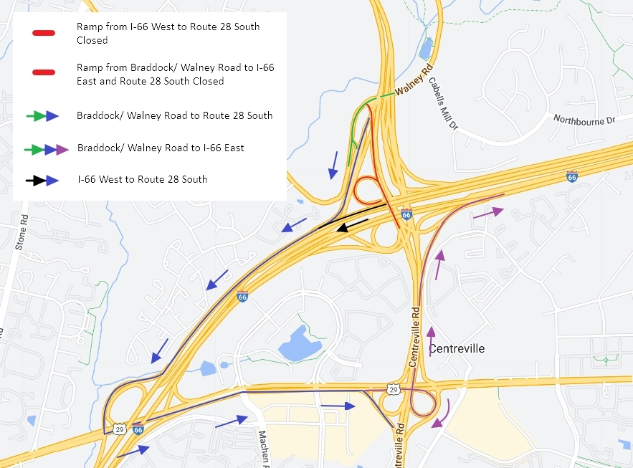
Thursday, January 12
Route 28 South approaching I-66
- Route 28 South approaching I-66 will be closed from 11 p.m. to 5 a.m.
- All traffic will be directed to I-66 West, exit to Route 29 Centreville, stay to the left and turn left at the traffic signal onto Route 29 North, then follow signs to Route 28 South.
- All lanes will reopen by 5 a.m.
Ramp from Route 28 South to I-66 East
- The ramp will be closed from 11 p.m. to 5 a.m.
- Traffic will be directed to I-66 West (prior to the closure), exit to Route 29 Centreville, stay to the left and turn left at the traffic signal onto Route 29 North, then follow signs to Route 28 North, then stay to the right to I-66 East.
Ramp from I-66 West to Route 28 South
- The ramp will be closed from 11 p.m. to 5 a.m.
- Traffic will be detoured farther west to Route 29 Centreville, stay to the left and turn left at the traffic signal onto Route 29 North, then follow signs to Route 28 South.
Ramp from Braddock Road/Walney Road to Route 28 South and I-66 East
- The ramp will be closed from 11 p.m. to 5 a.m.
- Traffic will be directed to I-66 West, exit to Route 29 Centreville, stay to the left and turn left at the traffic signal onto Route 29 North. Drivers traveling to Route 28 South will then follow signs to Route 28 South. Drivers traveling to I-66 East will follow signs to Route 28 North, then stay to the right to I-66 East.
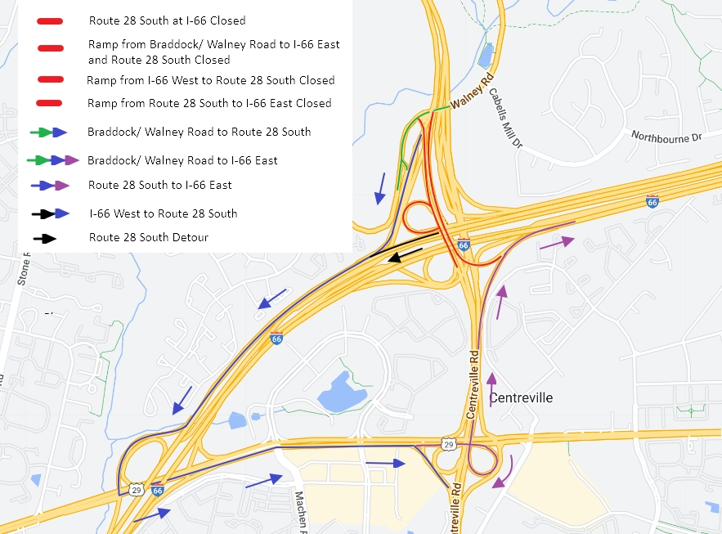

Construction and lane closure updates are available at Transform66.org and on Twitter @VaDOTNOVA.

###

