**GIS Locations for Site Plan Permit Submissions**

1. Go to this website: [Site Plan Entry Map](http://vdot.maps.arcgis.com/apps/GeoForm/index.html?appid=d7ac570fe7bc4b849c34994a590a1e56)
2. Or from this page, click on the link to the map application: <http://www.virginiadot.org/business/fairfax-permits-main.asp>
3. The Site Plan Entry map site looks like below

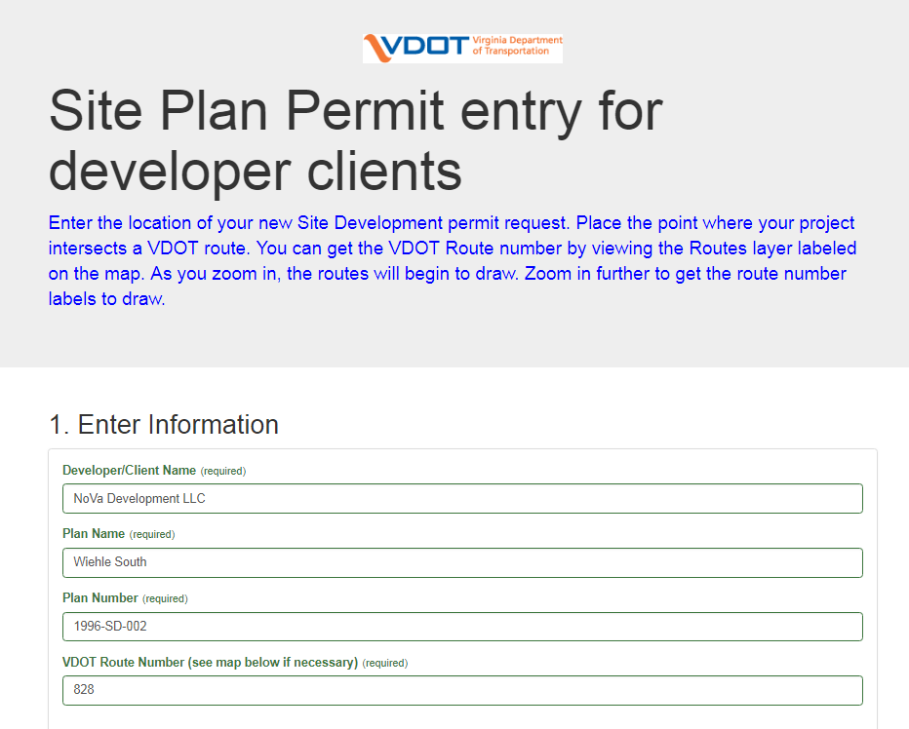

1. Enter the *required* information fields as shown in example above.
2. Find the location of your site on the map. You can zoom and pan to it or use the “Find Address” box.
3. Once you’ve clicked the map to place your point, you can drag it to your exact location if needed.

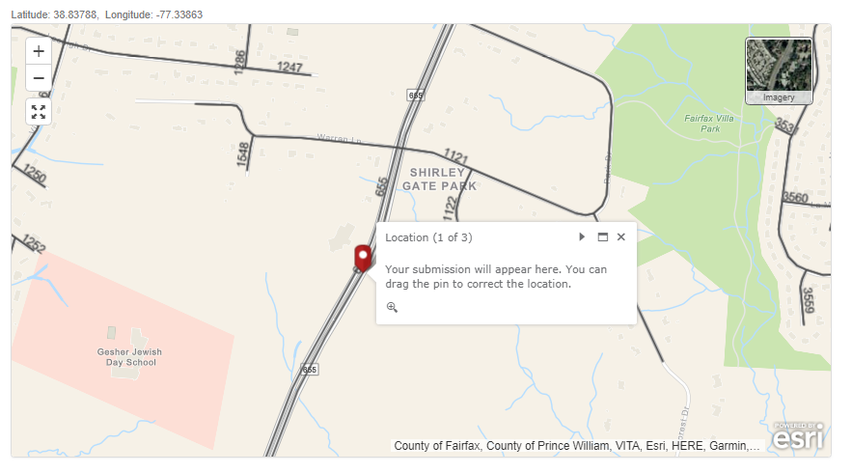

1. Click the blue Submit button and your point request is submitted.



1. The message below confirms your submission.

